Ormskirk West End Primary School
Calculation Policy 2025-2028

At Ormskirk West End, From EYFS- Year 6, we are using ‘White Rose’ format as a basis for our planning. This is used as a tool to support the teaching of the National Curriculum objectives.
We are using White Rose to meet the aims of the national Curriculum of:
- fluency
- reasoning
- problem-solving
In our maths work, we are using a CPA approach within our maths lessons (CPA – Concrete/ Pictorial/ Abstract) Whilst this calculation policy aims to show the CPA approach to the different calculations, it is not always noted further up the year groups. However, it is expected that the CPA approach is used continuously in all new learning and calculations even when not noted. This policy has been largely adapted from the White Rose Maths Hub Calculation Policy with further material added. It is a working document and will be revised and amended as necessary
We supplement the National Curriculum using: White Rose, NCETM Mastery documents & Nrich problems.
The aim is that when children leave Ormskirk West End they:
- Have a secure knowledge of number facts and a good understanding of the four calculation operations (addition, subtraction, multiplication and division)
- Make use of jottings, diagrams and informal notes to help record steps and part answers when using mental methods that generate more information than can be kept in their heads
- Have an efficient, reliable, written method of calculation for each operation that they are able to apply with confidence when they are unable to perform a calculation mentally

Progression in Calculations
In EYFS, our aim is to provide the children with opportunities to practise and improve their skills in counting numbers, calculating simple addition and subtraction problems, and to describe shapes, spaces, and measures. The White Rose scheme of learning meets these needs. The counting principles are the main driver of the curriculum. (one to one, stable order, cardinal, abstraction and order-irrelevance principle). We believe children should be exposed to different representations of mathematical concepts in order to embed conceptual understanding.
One of the aims under the Characteristics of Effective Learning is ‘creating and thinking critically.’ Children are encouraged to make links, find new ways to do things, solve problems, change strategies as needed, make predictions and develop ideas of grouping, sequencing, cause and effect.
Early Learning Goal for Number:
• Children can count reliably with numbers from 1 to 20, place them in order and say which number is one more or one less than a given number.
• Using quantities and objects, they add and subtract 2 single-digit numbers and count on or back to find the answer.
• They solve problems, including doubling, halving and sharing.
Development Matters:
EYFS Statutory Educational Programme:
Developing a strong grounding in number is essential so that all children develop the necessary building blocks to excel mathematically. Children should be able to count confidently, develop a deep understanding of the numbers to 10, the relationships between them and the patterns within those numbers. By providing frequent and varied opportunities to build and apply this understanding – such as using manipulatives, including small pebbles and tens frames for organising counting – children will develop a secure base of knowledge and vocabulary from which mastery of mathematics is built.
Mastering Number is being used in EYFS and KS1 to strengthen number knowledge and provide strong foundations for future maths learning.

Addition

 |  | Objective and Strategies | Concrete | Pictorial | Abstract
 |  | Year 1 | Use cubes to add two numbers together as a group or in a bar.  Explore aggregation (combining numbers and augmentation  (adding quantities)  8  1 |   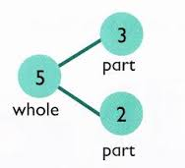  Use pictures to add two numbers together as a group or in a bar.  Use ten frames  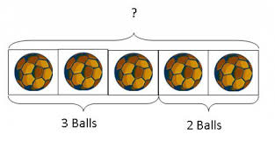  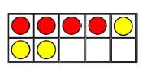 | 4 + 3 = 7  10= 6 + 4  5  3  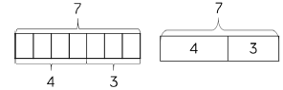  Use the part-part whole diagram and bar models as shown above to move into the abstract.
Y1 |  | WRM: Add 2 1 digit numbers to 10  Combining two parts to make a whole: part- whole model  Number bonds of 5, 6, 7, 8, 9, 10
Y1 & 2 |  | Counting  WRM: ‘Adding 1 and 2 digit numbers to 20’  Starting at the largest number and counting on | Use groups of straws, dienes or numicon to group the numbers.  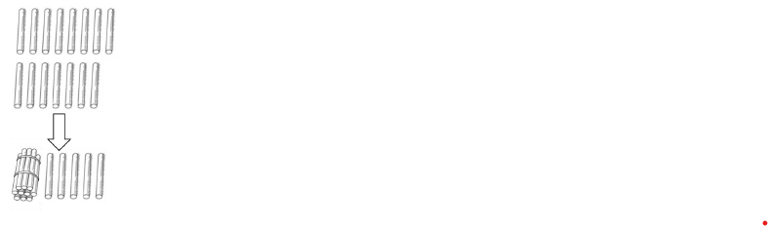  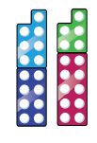  When adding 1 digit numbers, the importance of 10 ones equalling one ten must be made.  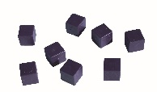 | 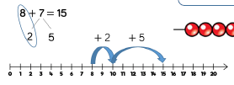  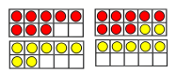  Partitioned jumps can be used to strengthen number knowledge and make calculations more efficient.  Start at the larger number on the number line and count on in ones or in one jump to find the answer. (ten frames support this) | 5 + 12 = 17  8 + 8 =
Y2 |  | Adding three single digits | 3 + 7 + 6= 16  Put 3 and 7 together to make 10. Add on 6.  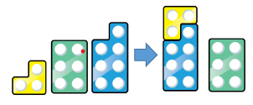  Following on from making 10, make 10 with 2 of the digits (if possible) then add on the third digit. | 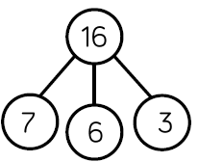  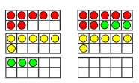  Add together three groups of objects. Use ten frames to recombine the groups to make 10. Supports understanding of commutativity | 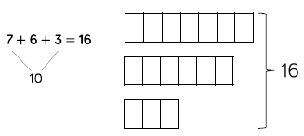  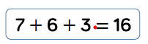  Combine the two numbers that make 10 and then add on the remainder.
Y2 & Y3 |  | Add 1 and 2 digit numbers to 100 | When adding on single digits count on from the larger number.  Hundred squares can support number bonds to 10.  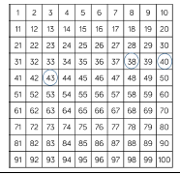  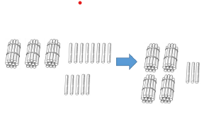 | After practically using the base 10 blocks, children can draw the ten sticks and ones to help them to solve additions.  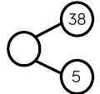  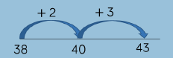  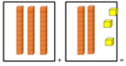 | 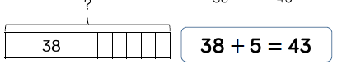  Apply knowledge of number bonds to add efficiently  e.g 8+5=13 so  38+5=43
Y2 & Y3 |  | Add two 2 digit numbers to 100 | 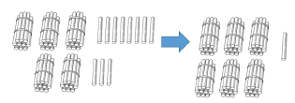 | 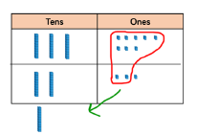  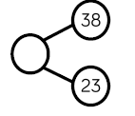  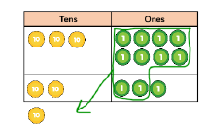  Develop uderstand of column method using base ten representations and place value counters. Move away from straws when using larger numbers (not efficient) | 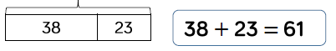  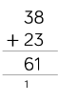  Move to the formal method of column addition.
Y3 |  | Add numbers with up to 3 digits | Make both numbers on a place value grid. Base 10 is also effective for adding numbers with 3 digits  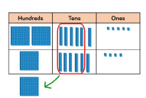  Add up the ones and exchange 10 ones for one 10.  Add up the rest of the columns, exchanging the 10 counters from one column for the next place value column until every column has been added.  Show the written method next to any concrete resources to make links between both | Children can draw a pictoral representation of the columns and place value counters to further support their learning and understanding.  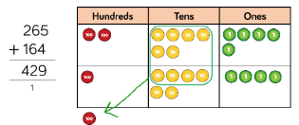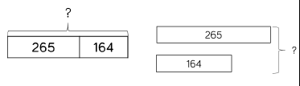 | Start by partitioning the numbers before moving on to clearly show the exchange below the addition.  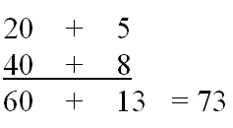
Y4 |  | Add numbers with up to 4 digits | Continue use of base ten and place value counters. | 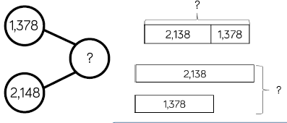  Explore parts and wholes and the relevant inverses. | 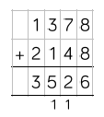  Column method showing exchanges
Y5 & 6 |  | Add numbers with more than 4 digits | 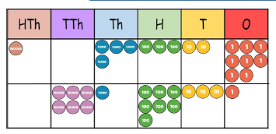  Place value counters or plain counters on pv grids | 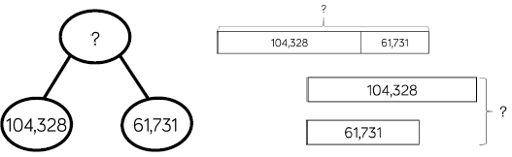 | 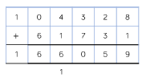
Y5 & 6 |  | Add with up to 3dp | 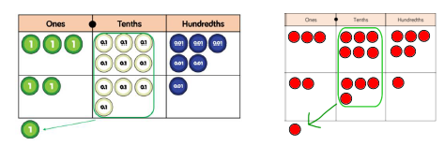  Work up in stages- 1dp, 2dp and 3dp. Counters on pv grids best manipulatives. | 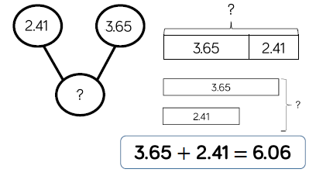 | 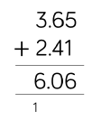  Ensure context is used- money/ measures etc

Subtraction
 | Objective and Strategies | Concrete | Pictorial | Abstract
Y1 | Subtract 1 digit numbers within 10 |   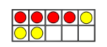  7-3  Ten frames support ‘reduction’  Numicon supports partitioning with part whole models.  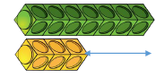  Cubes can be used for ‘find the difference’ | Cross out drawn objects to show what has been taken away.  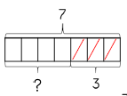 | 8 – 2 = 6
Y1/2 | Subtract 1 and 2 digit numbers to 20 | Make the larger number in your subtraction using base 10 or with straw bundles. Highlight the importance of 10 ones making one 10.  Create equal sized bars using Numicon, partition the bar using the numbers in the sentence. E.g. 14-6=8  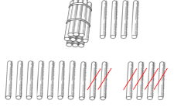  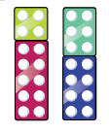 | 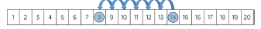  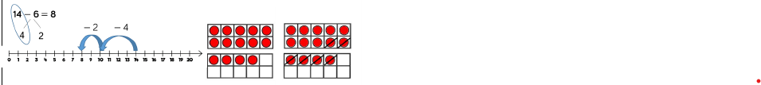  Find number bonds to 10 when partitioning the subtracted number e.g. 14-6 would become 14-4 -2. | 14-6=
Y2 | Subtract 1 and 2 digit numbers to 100 | Base 10 and place value counters (tens and ones) show the written calculation next to the concrete  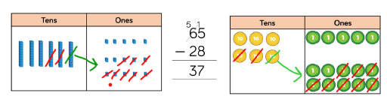 | 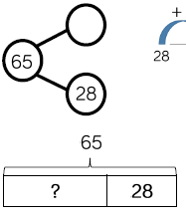  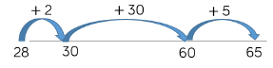  Number lines are useful for counting on to find the difference. For efficiency, jump to mults of 10. | 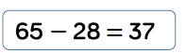  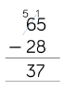
Y3 | Subtract numbers with up to 3 digits | 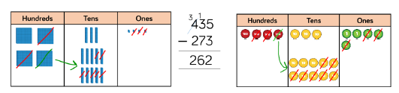  Base 10 and pv counters most effective manipulatives | 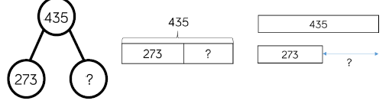  Explore relationships using bar models and part-whole models. | 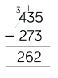
Y4 | Subtract numbers up to 4 digits | 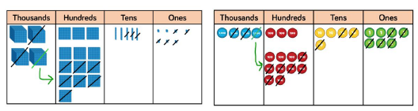  base 10, pv counters and plain counters can be used. | 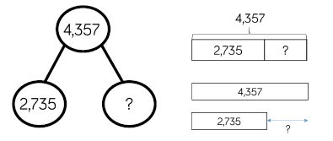 | 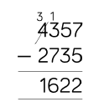
Y 56 | Subtract numbers with more than 4 digits | 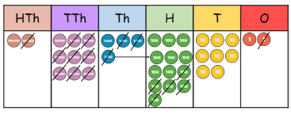 | 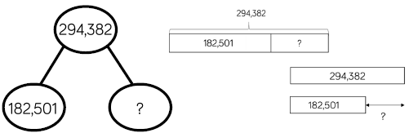 | 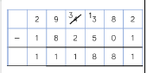
Y5 | Subtract with up to 3 dp | 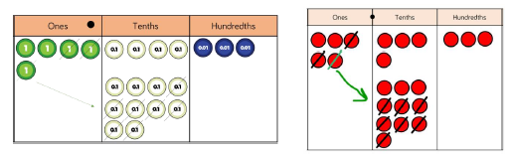  pv counters and plain counters | 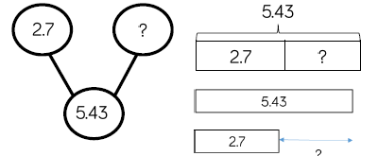 | 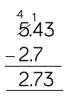  Ensure children experience subtracting decimals with different amounts of dp (consider context of money and measures)

Multiplication
Part 1- times tables. We expect our children to have a good understanding and fluent recall of this by Year 4 (in line with the National TT Check. We continue to promote the learning of times tables through UKS2.
Objective and Strategies | Concrete | Pictorial | Abstract
(Year 2)  Recall and use times tables facts for the 2x 5x and 10x tables | 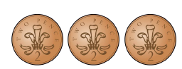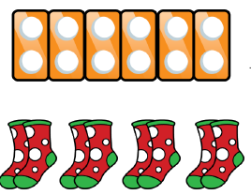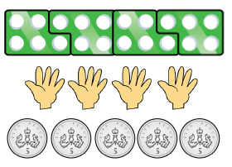  Use a variety of models to develop fluency | 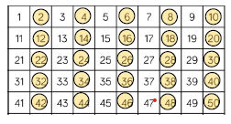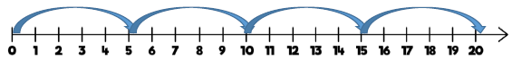 | Look for patterns- even numbers for twos  Pattern of odd, even, odd, even in fives  Pattern- 10s all end in zero.
(Year 3)  Recall facts for the 4 and 8 times tables | 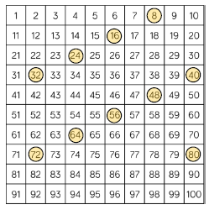    Look for crossover patterns- multiples of 4 one colour counter and multiples of 8 another colour- what patterns are noticed? | 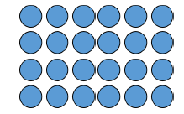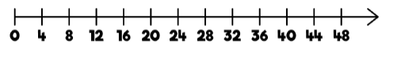  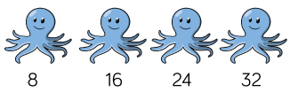 |  | 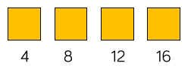  Identify patterns within each group of 5 multiples.  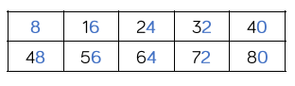
(Year 3)  Recall facts for the 3x and 6x tables |    | 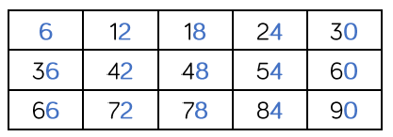  Recognise the pattern for every 5 multiples of 6.  Number lines and counting sticks will support recall. |  | Make links between the 3x and 6x table- every multiple of 6 is a multiple of 3 doubled.
(Year 4)  Recall facts for the 9x tables | 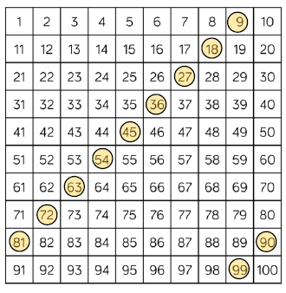  Identify multiples using clear counters.  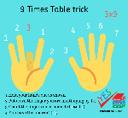 | 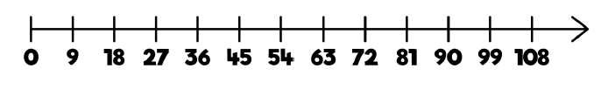
(Year 4)  Recall facts for the 7x tables |   Numicon will help identify the odd, even, odd pattern. | 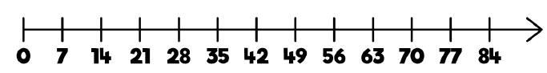
(Year 4)  Recall facts for the 11x tables | 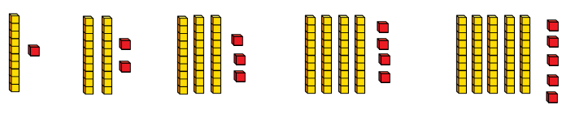  Use of Base 10 rather than Numicon is the most appropriate representation.  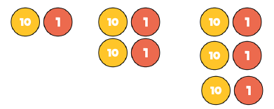 | 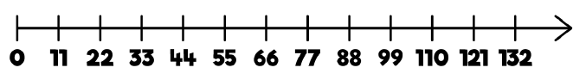
(Year 4)  Recall facts for the 12x tables | 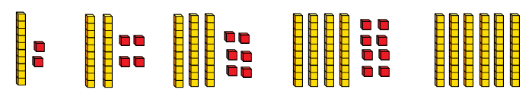  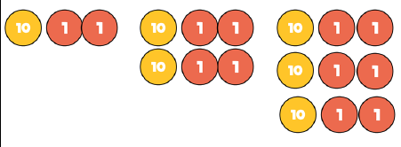 | 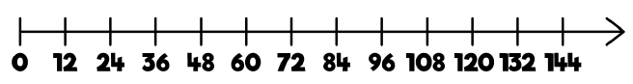 |  | 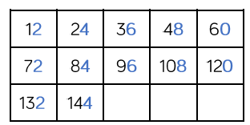  Look for the patterns- just like the 6x every 5 multiples has a pattern.
Year 1 & 2  Solve one step problems with multiplication  (Year 1- concrete and pictorial expected  Year 2- multiplication symbol and recorded calcs) | 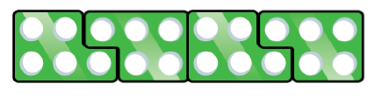  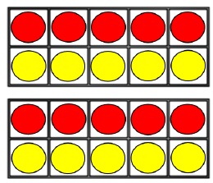 | 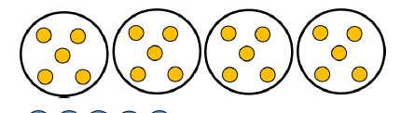  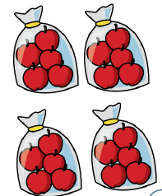  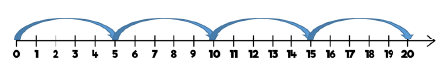 |  | 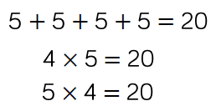
Year 3 & 4  Multiply 2 digits by 1 digit number | Place value counters can be used to support this.  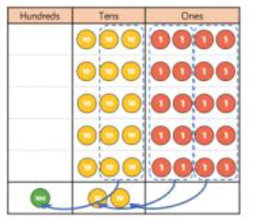 | 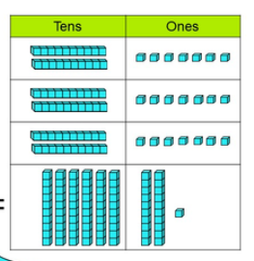  Representation of Base 10 can be used (sticks and dots) Times table knowledge should be utilised |  | 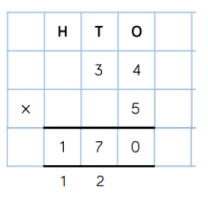  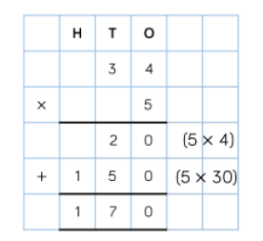  Both the expanded and the contracted method (using exchanges) are modelled and used.
Year 3 & 4  Multiply 3 digit by 1 digit | Visual use of base 10 but shouldn’t be necessary at this point. | 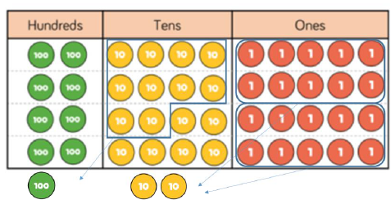  Pv counters if necessary |  | 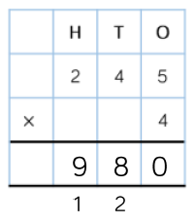
Year 5  Multiply 4 digit by 1 digit | Pv counters | 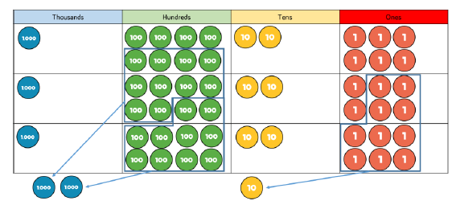 |  | 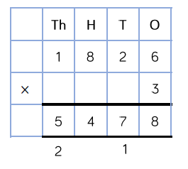  Ensure children work from smallest digit to largest digit
Year 5  Multiply 2 digit by 2 digit | Use of playing cards  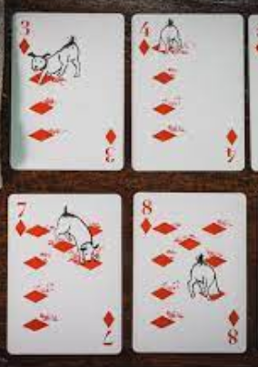 | 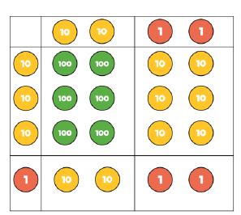 |  | Use of the grid method is used as a step before using long multiplication.  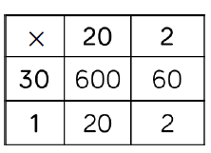  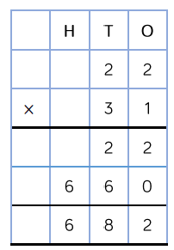
Multiply 3 digit by 2 digit numbers |  | 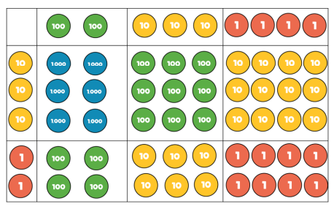 |  | 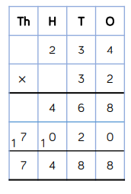  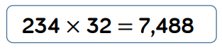
Multiply 4 digit by 2 digit numbers |  | When multiplying 4- digits by 2-digits, children should be confident in using the formal written method. If they are still struggling with times tables, provide multiplication grids to support when they are focusing on the use of the method. Consider where exchanged digits are placed and make sure this is consistent. |  | 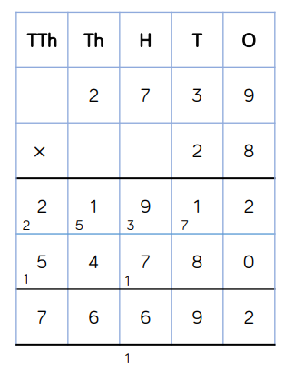  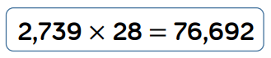

Division
Objective and Strategies | Concrete | Pictorial | Abstract
Y1/2  Solve one step problems using multiplication (sharing) | 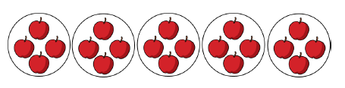  Using cubes  Year 1 main focus is concrete and pictorial representations (no expectation to record division formally) | 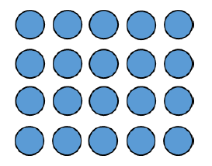 | 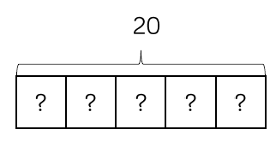  20÷5=  In year 2, children are introduced to the division symbol
Solve 1 step problems using grouping. |   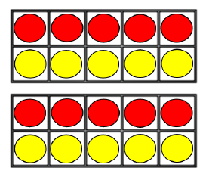  Division is solved by grouping and counting the amount of groups. This encourages the counting of multiples. | 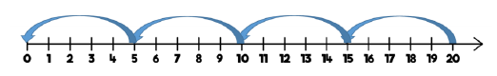  Number lines support the visual of ‘equal’ groups  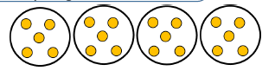 | 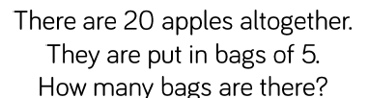  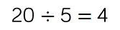
Year 3  Divide 2 digit by one digit with no exchanges. | 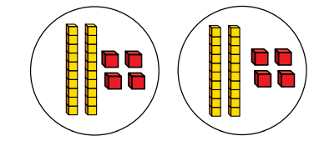  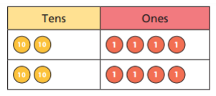  When dividing larger numbers, children can use manipulatives that allow them to partition into tens and ones. | Part-whole models can provide children  with a clear written method that matches the concrete  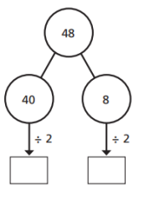  representation. | 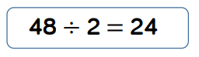
Year 3 / 4  Divide 2 digit by one digit with exchanges. | Children can use base 10 or pv counters to show exchanges of tens.  Again, start this process without the pv grid.  This is vital for the conceptual understanding in the bus stop method. 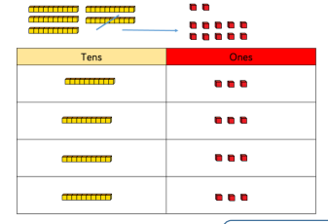 | 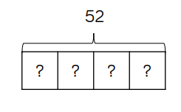  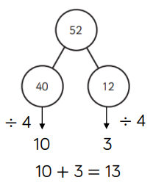  Flexible partitioning in a part-whole model supports this method. | 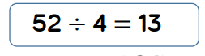  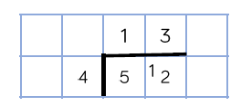
Year 3/ 4  Divide 2 digit by 1 digit with remainders | 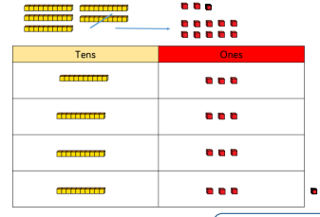 | 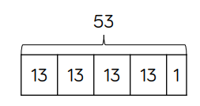  Flexible partitioning in  a part-whole model  supports this method. | 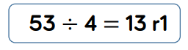
Year 4  Divide 3 digits by 1 digit (sharing) | 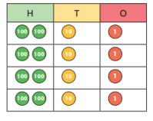  Children can continue to use place value counters to share 3- digit numbers into equal groups. | 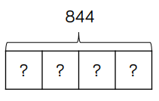  Flexible partitioning in a part-whole model supports this method. | 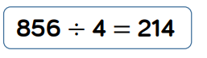
Year 4/ 5  Divide 2 digits by 1 digit (grouping) | 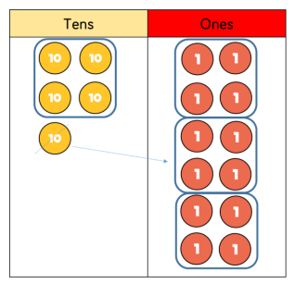 | 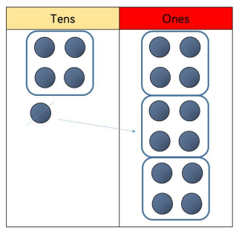 | 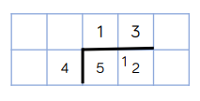  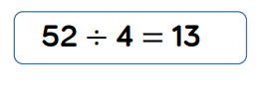  When using the short division method, children use grouping. Starting with the largest place value, they group by the divisor.  Language is important here. Children should consider ‘How many groups of 4 tens can we make?’ and ‘How many groups of 4 ones can we make?’ Remainders can also be seen as they are left ungrouped.
Year 5  Divide 3 digits by 1 digit (grouping) | Place value counters or plain counters can be used on a place value grid to support this understanding. Children can also draw their own counters and group them through a more pictorial method. | 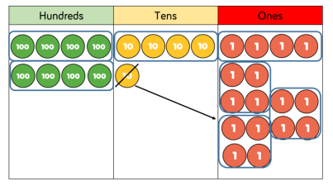 | 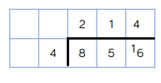  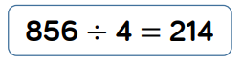
Year 5  Divide 4 digits by 1 digit (grouping) | Children should be encouraged to move away from the concrete and pictorial when dividing numbers with multiple exchanges. | 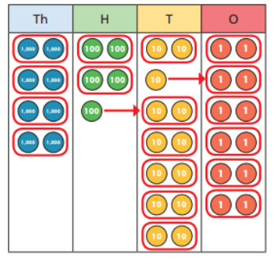 | 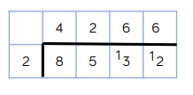  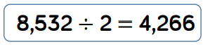
Year 6  Divide multi digits by 2 digits (short division) |  | 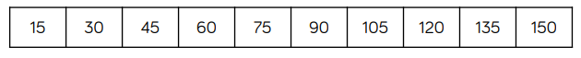 | 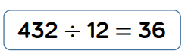  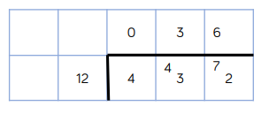  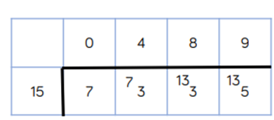  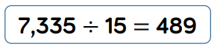
Year 6  Divide multi digits by 2 digits without remainders (long division/ chunking) |  | Children can also divide by 2-digit numbers using long division. Children can write out multiples to support their calculations with larger remainders. Children will also solve problems with remainders where the quotient can be rounded as appropriate. | 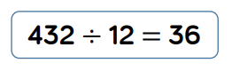  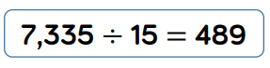  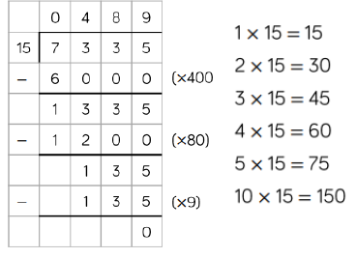  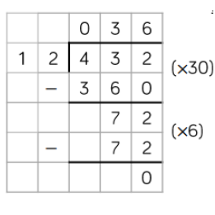
Year 6  Divide multi digits by 2 digits with remainders (long division/ chunking |  |  | 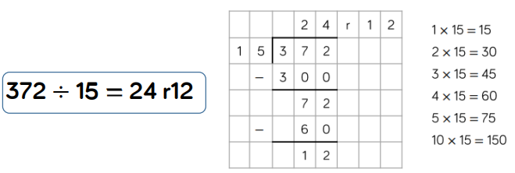  Remainders will appear as decimals rather than fractions e.g. 4/5= 0.8  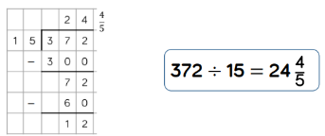

Glossary of terminology:
Division and multiplication
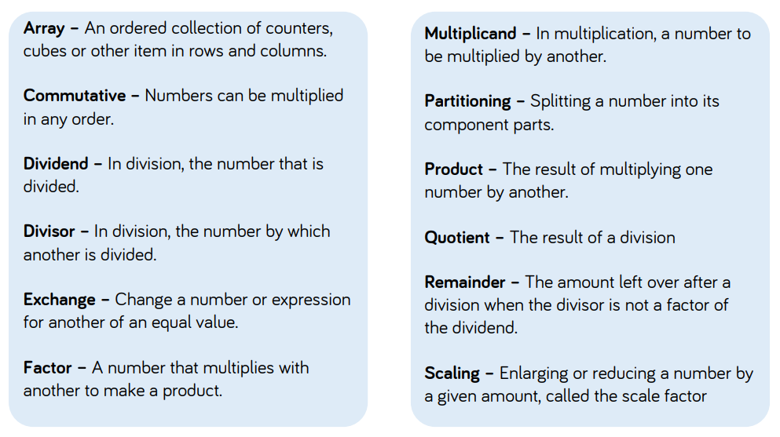
Glossary of terminology:
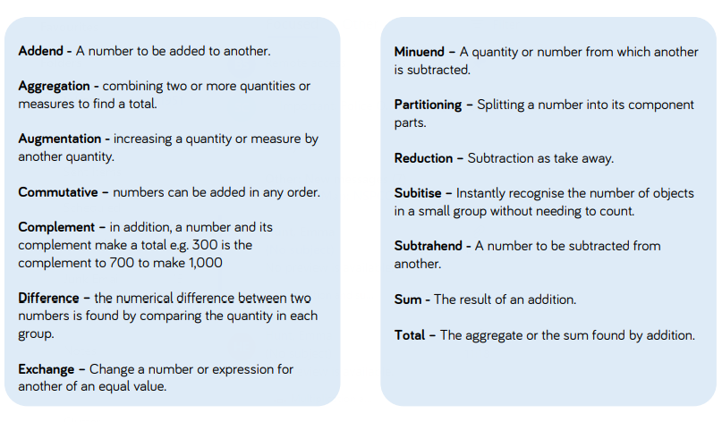
Addition and Subtraction

